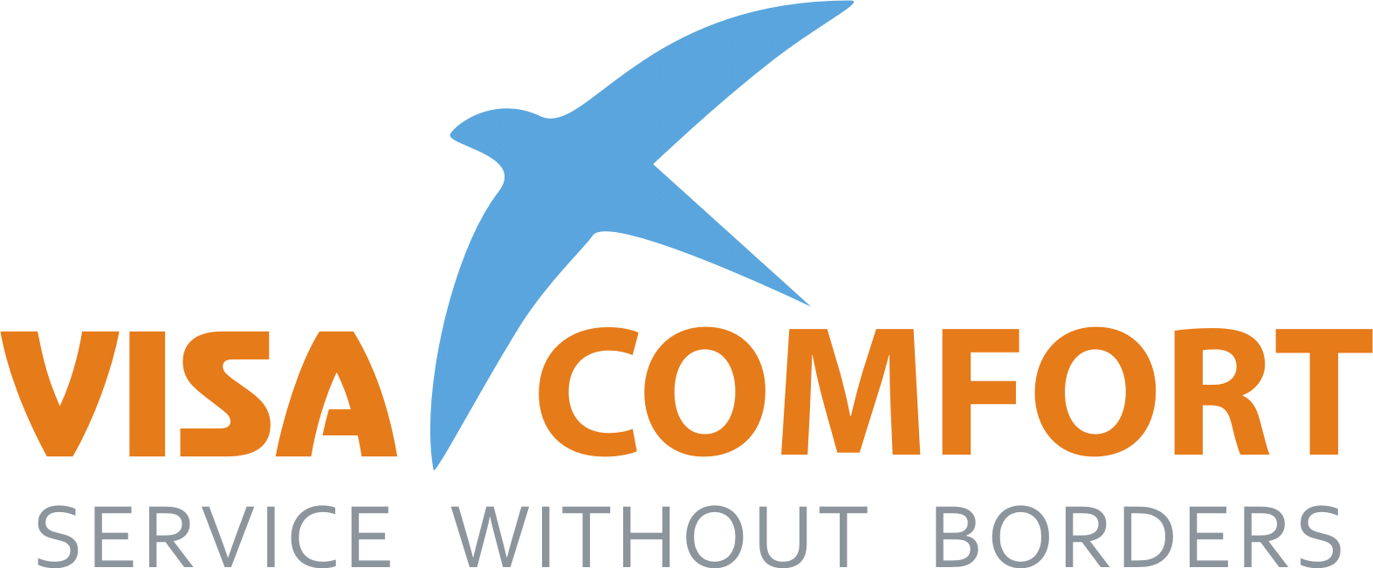
 | Visa-Comfort Ltd.  119415, Moscow, Prospekt Vernadskogo, 39, off.416  Internet: www.visatogermany.ru | Tel: +7 (495) 987 17 14  Fax +7 (495) 789 64 33  E-Mail: info@visacomfort.ru
_________________________________________________________________________________________________________________________________________________________

Please complete the Credit Card Authorization Form if you choose to pay by Credit Card
Please send a photocopy of both sides of your Credit Card with this Authorization Form

Additional Instructions

Credit Card Authorization Form

I authorize Visa Comfort to charge my credit card № specified below
for the travel arrangement requested by me over the phone or via e-mail.

Master Card  VISA American Express Corporate

Issued by: Company (if corporate):

Card number: Expiry date:
/__/__/__/__/__/__/__/__/__/__/__/__/__/__/__/__/ /__/__/__/__/__/__/
day month year Cardholder’s Name:

Cardholder’s Contact Phone: Country:

Cardholder’s Permanent Phone: Country:

RUB Amount in Words: In Figures: RUB

I hereby agree to pay accordingly to the details stated above

Signature:

Date: /__/__/__/__/__/__/

day month year

Prospekt Vernadskogo. 39, off.416 • 119415 Moscow • Russia
Local Phone: +7 (495) 987-17-14 Local Fax: +7 (495) 789-64-33

